PROJECT PLAN

members: Ishant upadhyay, Ji nan, Raditya surya pratama, hamid reza, hasan lapa,francky Ngabo

Group-B

Traffic-kings

2015

Contents

**INTRODUCTION** 2

**PROJECT STATEMENT** 3

1. Formal Client 3

2. Project Leader 3

3. Current Situation 3

4. Project justification 3

5. Project Product 3

6. Project deliverable and non-deliverable 3

Deliverables: 3

Non-Deliverable: 3

7. Project Constraint 4

Time 4

Founding 4

Programming techniques and tools for development 4

8. Risks 4

**Project Phasing** 5

Phase 1: Requirement Gatherings 5

Phase 2: Initiations 5

Phase 3: Building 6

Phase 4: Finalization 6

**Project Management** 7

Money 7

Skills 7

Quality 7

Time 8

Time schedule 8

Information 9

Abbreviations 9

Organization 9

# **INTRODUCTION**

We have been given to make a traffic light simulation.

This traffic light will be reducing the number of accidents, traffic jams and other undesirable situations on the road.

This traffic light will be done by an expert group of student from Fontys composed by six students.

So this whole project plan will give the overview of our timing, budgets and information about the members of group.

## **PROJECT STATEMENT**

## Formal Client

Mr. George, who is primarily responsible for the traffic situation.

## Project Leader

Ishant Upadhyay, student at Fontys Hogeschool.

## Current Situation

* 1. The project study, research and his implementation. In order to reduce the number of accidents and other undesirable traffics on the road like.
  2. The general description of the project was given.

## Project justification

Implementation of a good and cheap traffic system simulation in the city. The simulation will help our potential client to choose what will suit the city to avoid or reduce traffics jams, and accidents.

## Project Product

* 1. A traffic-simulation program that will enable the user to investigate the impact of traffic lights and see how much the traffic would be affected.
  2. To make better choice for the adjustable, security, of the traffic light within low price and to avoid all traffic problem of the city

1. Project deliverable and non-deliverable

### Deliverables:

* Provide a project plan
* Provide URS
* Provide test plan and test cases
* Provide a design for the app
* Provide the actual application and the code for it
* Provide a process report and a final presentation with a demo of the application.
* Manual about how to use it.

### Non-Deliverable:

* Training of the users of the application
* Application running on an android device (Phone, tablet…).

## Project Constraint

### Time

We only have about 6 months to finish all documentation, software creation. We have a lot of ideas but cannot implement them due to the time constraint.

### Founding

Project funding sources are limited.

### Programming techniques and tools for development

* Object oriented languages - C# on Visual Studio 12.

## Risks

* If the application crash : We have a professional software developers working with us to solve the problem and should be fixed in short period of time.
* We may exceed the limited budget.

# **Project Phasing**

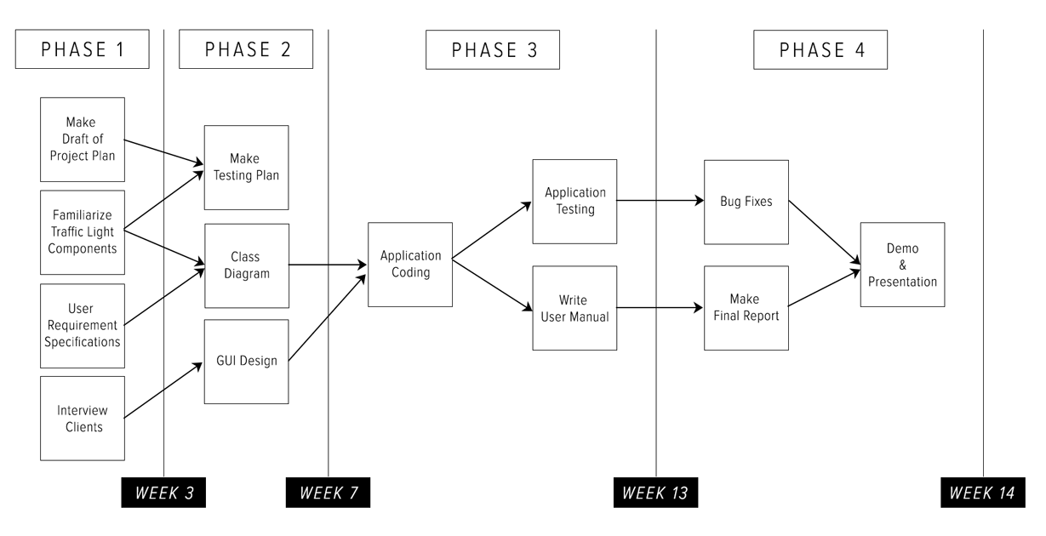

## Phase 1: Requirement Gatherings

Activities of this phase are:

1. Make a Draft of Project Plan
   1. Project Statement
   2. Project Phase
   3. Project Management(MOSQUITO)
2. Familiarize Traffic Light Components
3. User Requirement Specifications
   1. Uses Cases
   2. Function Requirements
   3. Non-Function Requirements
4. Interview Client
   1. Create Questions

Deliverables for milestone **P1** are:

1. First Draft Project Plan
2. URS

## Phase 2: Initiations

Activities of this phase are:

1. Make Testing Plan scenarios
2. Class Diagram
   1. Discuss Class Diagram
   2. List every class with description
3. GUI Design
   1. Create GUI Sketches of the application

Deliverables for milestone **P2** are:

1. Test Plan
2. GUI Sketches & Wireframe
3. Class Diagram

## Phase 3: Building

Activities of this phase are:

1. Coding the application
2. Test the application
3. Write the manual

Deliverables for milestone **P3** are:

1. C# Application
2. User Manual
3. Testing Report

## Phase 4: Finalization

Activities of this phase are:

1. Bug Fixing
2. Make Final Report
3. Demo & Presentation

Deliverables for milestone **P4** are:

1. Final Report
2. Final Version of C# Application

# **Project Management**

### Money

**Costs:**

* Traffic-simulation application – 10500€
* Software Developers (6 )-1750/ per person
* Traffic-simulation server – 800€

**Total cost**: €11300.

**Profits:**

*There is profit in this project, but cannot be determined by the monetary values, this profit is the city will get a good traffic light system.*

### Skills

* **Project Management** skills are required to make sure the project runs smoothly.
* For **URS**, members must have good knowledge about designing user Interface and making Use-cases.
* For **Design Document**, member must have good knowledge about classes, methods, attributes and properties.
* Good knowledge of **C Sharp.**
* For **Testplan,** everybody should know how use-case works.
* **Teamwork skills** - with the aim of genuinely cooperating between our teammates

### Quality

We will assure that the traffic-simulation application will fulfill all the requirements specified by Mr. Boots. We will be available to the client at all times to make sure we are all on the same way and working towards the same goals.

To achieve the best quality of the project we have quality plan:

|  |  |  |
| --- | --- | --- |
| Deliverable | Quality Event | Purpose |
| First version of Project Plan | Expert Review | Ensure the information is accurate and well  constructed |
| Final version of Project Plan | Peer Review of  final draft | Ensure the Project Plan is in a fit state to be submitted to the client |
| First version of User Requirement Specification | Expert Review for completeness of URS | Ensure that all requirements are fulfilled |
| Final version of User Requirement Specification | Peer Review of  final draft | Ensure that all functional and non-functional requirements are accurate |
| First version of Test Plan | Walk-through  of early draft | Review early draft for completeness |
| Final version of Test Plan | Peer Review of  final draft | Ensure that all possible test scenarios are considered |
| First version of Design Document | Expert Review | Review early draft for  completeness |
| Final version of Design Document | Peer Review of  final draft | Review final draft for completeness and  construction |

### Time

In this part of the project plan we will determine the needed time and deadlines to deliver the sub-deliverables. The specified period for this project is 6 months which is divided into two periods of 7 weeks. This time schedule might change during the project progress.

The main sub-deliverables for “Traffic Control Simulation” project:

* Project plan *(PP)*
* User requirements specifications *(URS)*
* Test plan *(TP)*
* Design Document of the project *(DD)*
* Final project – Implementation of the project
* Process report *(PR)*
* Presentation *(PRS)*

### Time schedule

|  |  |  |  |  |
| --- | --- | --- | --- | --- |
| First period | | | | |
| Sub-Deliverable | | **Start date** | **End date** | **Assessment** |
| Phase I | PP | Week 1 | Week 2 | Week 3 |
| URS | Week 2 | Week 3 | Week 3 |
| Phase II | TP | Week 4 | Week 5 | Week 5 |
| GUI | Week 6 | Week 7 | Week 7 |
| Second period | | | | |
| Sub-Deliverable | | **Start date** | **End date** | **Assessment** |
| Phase III | Final Project  (Implementation) | Week 7 – Week 13 | Week 13 | Week 13 |
| Phase IV | Final Report | Week 14 | Week 14 | - |
| Presentation &Demo | Week 14 | Week 14 | _ |

### 

### Information

The following table shows the responsibility of each member who participate in this project.

|  |  |  |  |  |  |  |  |
| --- | --- | --- | --- | --- | --- | --- | --- |
|  | PP | URS | TP | DD | PR | MN | AG |
| Formal client | A, R | A, R | A, R | A, R | A, R | - | - |
| Project leader | Dr | Dr | Dr | Dr | Dr | A | A |
| Chairman | Di | Di | Di | Di | Di | Di | Dr |
| Secretary | S, Ar | S, Ar | S, Ar | S, Ar | S, Ar | Dr, S, Ar | S, Ar |
| Team member | Di | Di | Di | Di | Di | Di | Di |

### Abbreviations

|  |  |
| --- | --- |
| * PP: Project Plan * URS: User Requirements Specifications * TP: Test Plan * DD: Design Document * PR: Process/Project Report * MN: Minutes * AG: Agenda | * A: Approve * Di: Discuss * Dr: Draw up * S: Send * Ar: Archive * R: Receive |

### Organization